**ASSIGNMENT 6.1**

**on**

**Collaboration**

**Submitted by:**

**Haseebullah Shaikh (2303.KHI.DEG.015)**

**Faiza Gulzar Ahmed (2303.KHI.DEG.001)**

**and**

**Aqsa Tauheed (2303.KHI.DEG.001)**

**Dated:** 22nd May 2023

**Solution:**

We have created the project Inventory Management System, in which we have one sprint of two weeks

The project has four main functionalities:

1. Managing Customers
2. Managing Suppliers
3. Managing Inventory Stock
4. Managing Purchase Invoices
5. Managing Sales Invoices

We have created two epics,

1. Front-end

Frontend contains the 5 User stories for above functionalities along with their descriptions, subtasks, effort estimations and responsible team members.

1. Back-end (Database)

Backend contains the 5 main tasks of creating tables for storing the data of above operations along with description, effort estimation and responsible team members.

**Board**

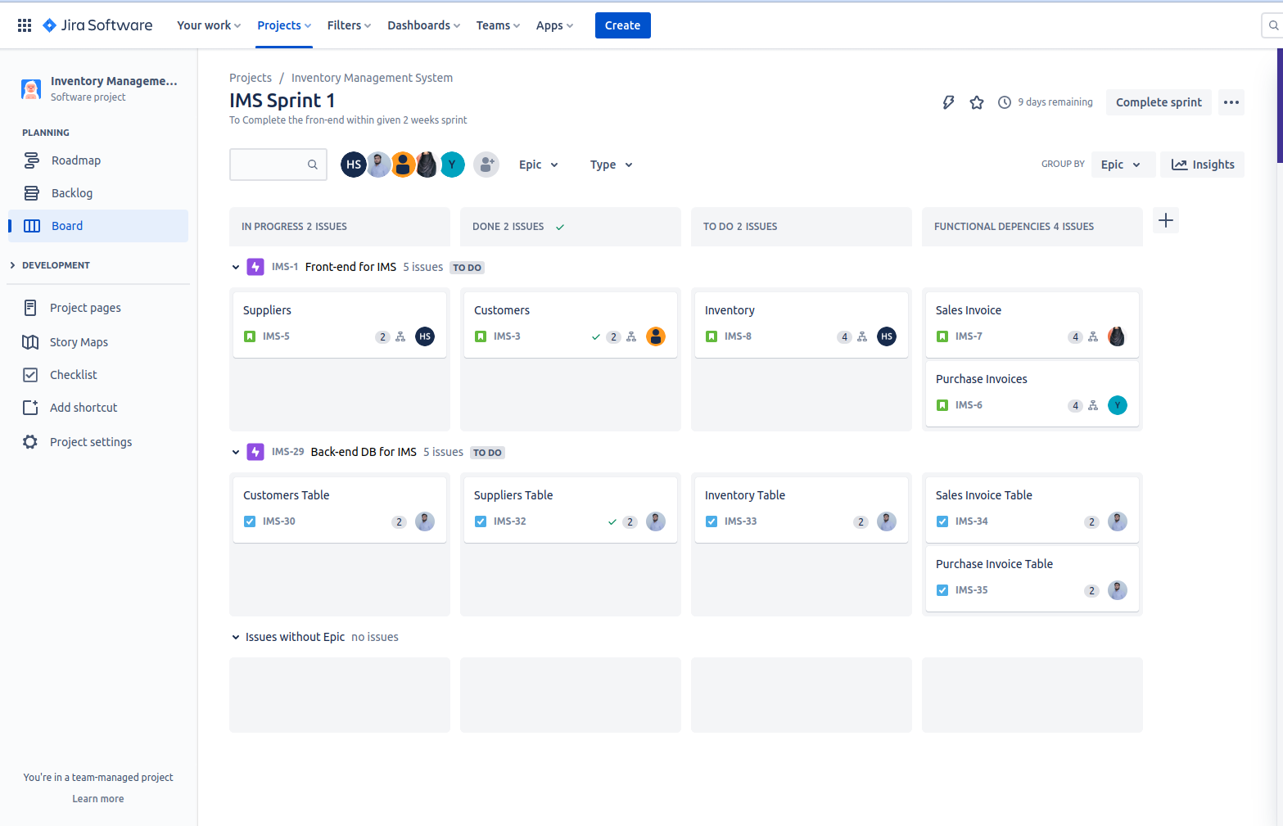

**Backlog  
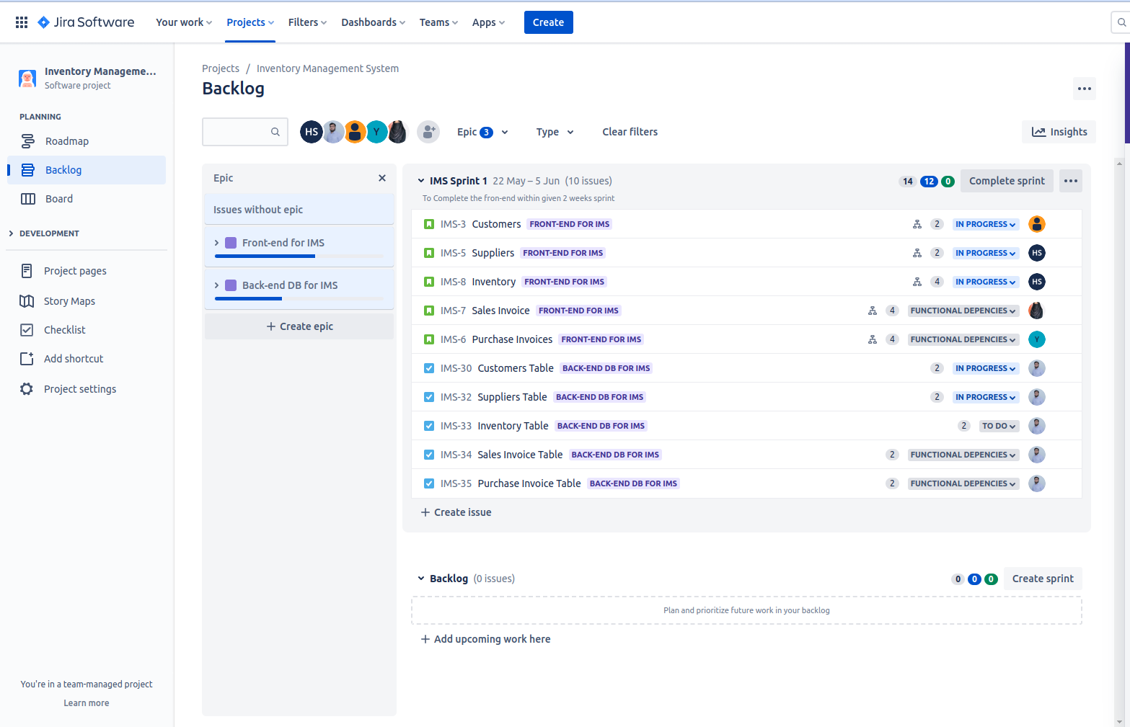**

**Epic1: Front-end : 05 User stories, their subtasks and other details**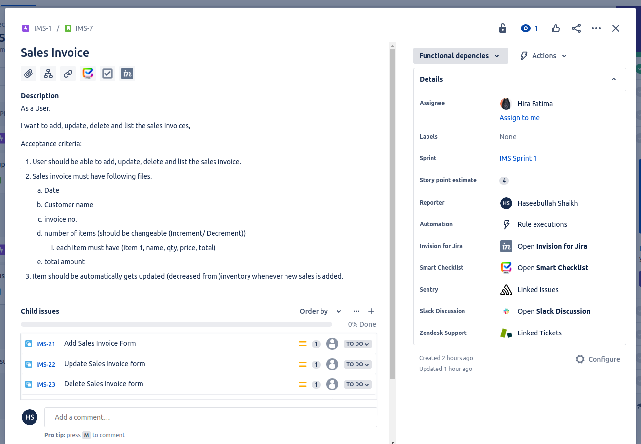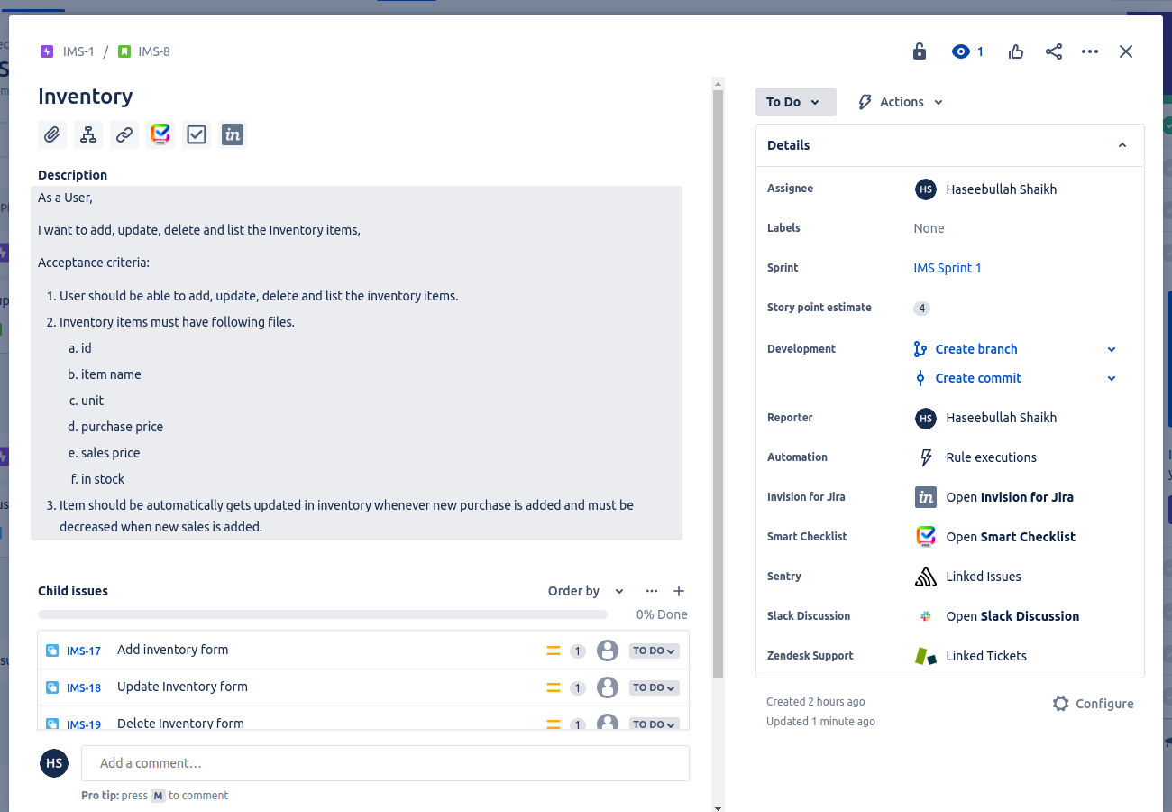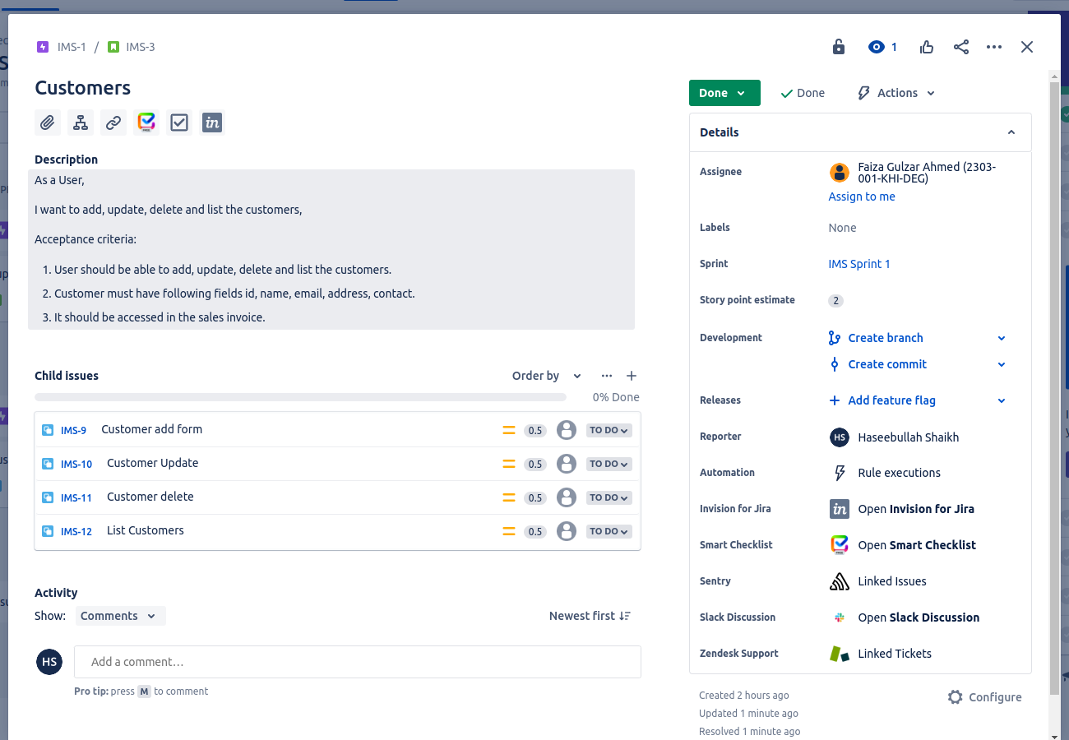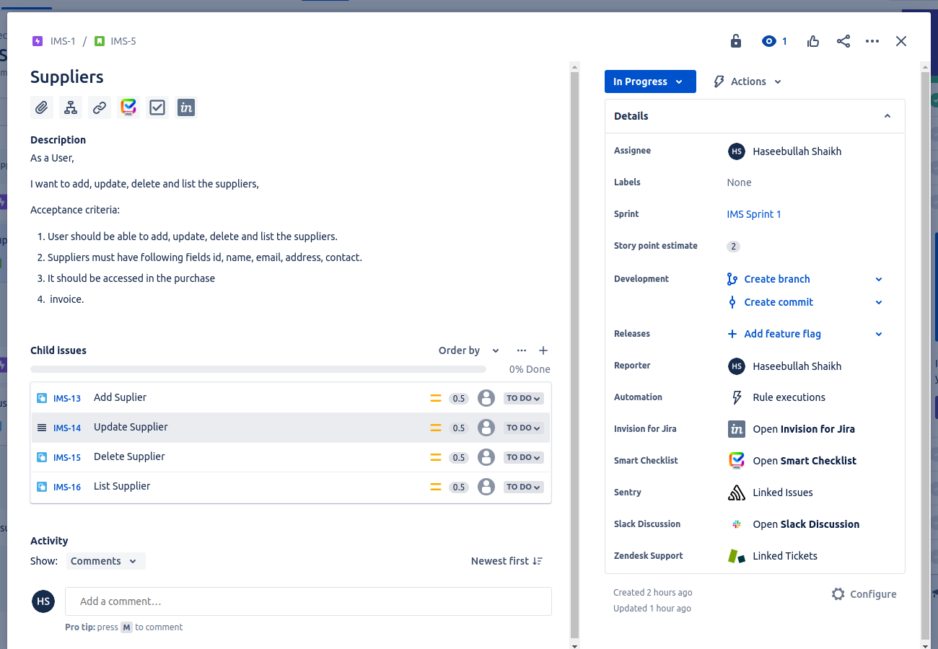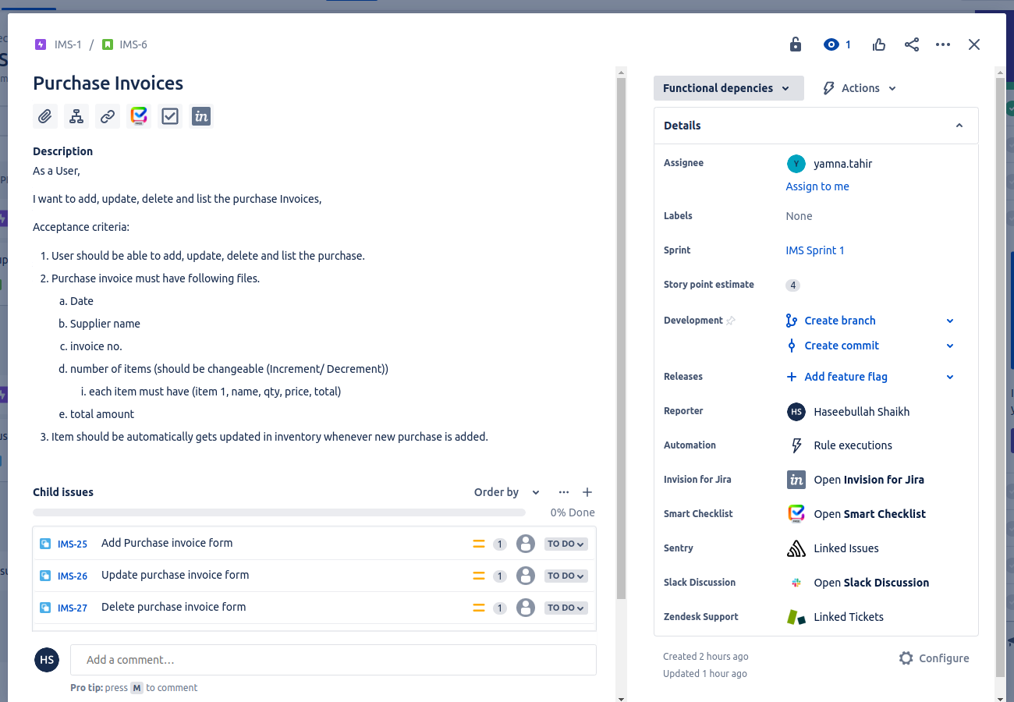

**Epic 02: Backend DB, its 5 tasks and their details.**

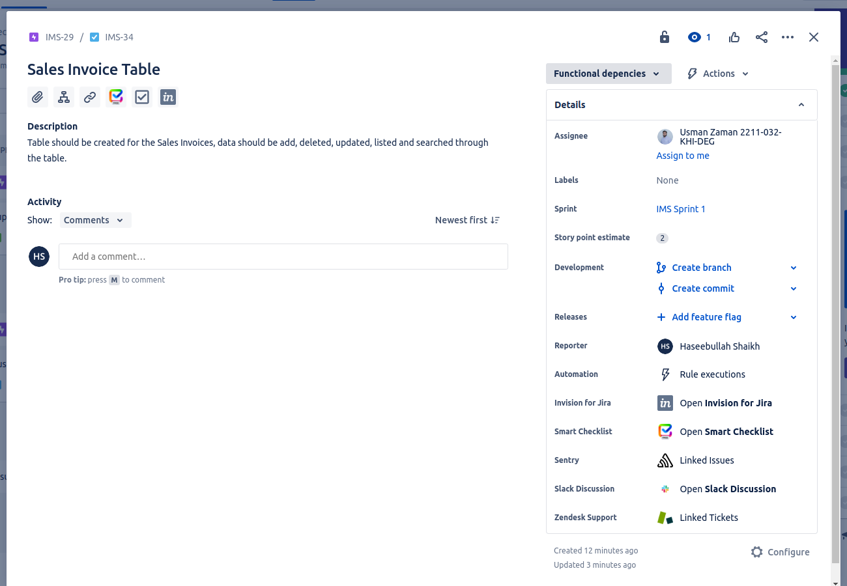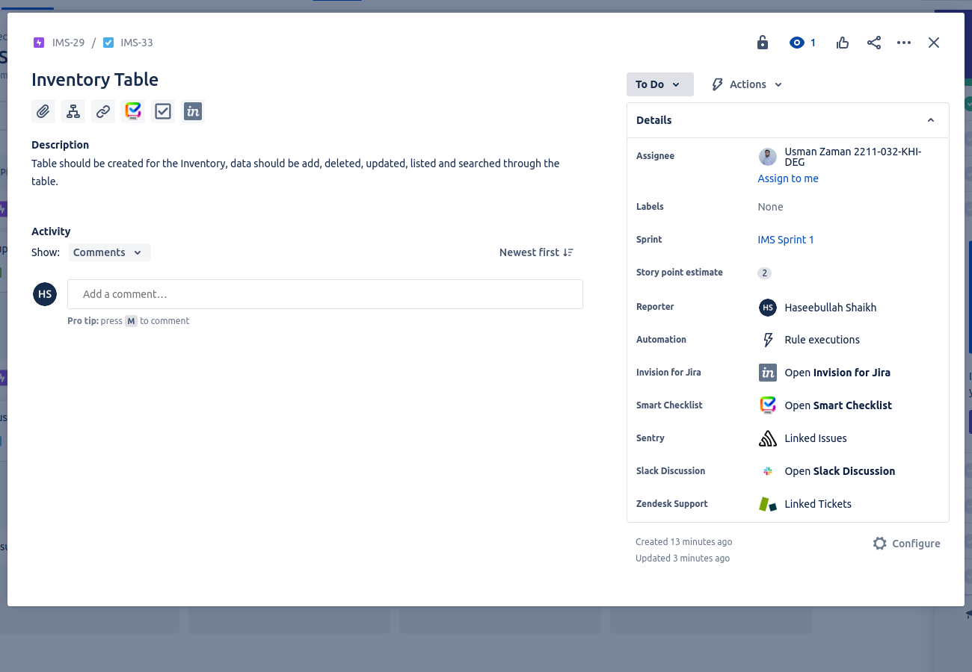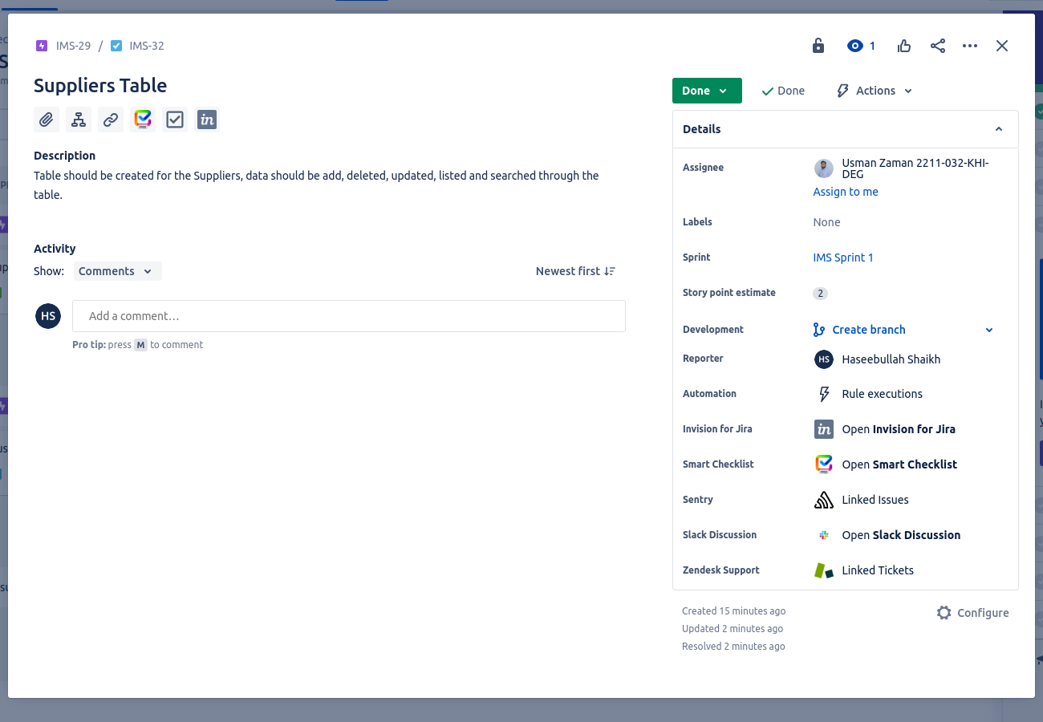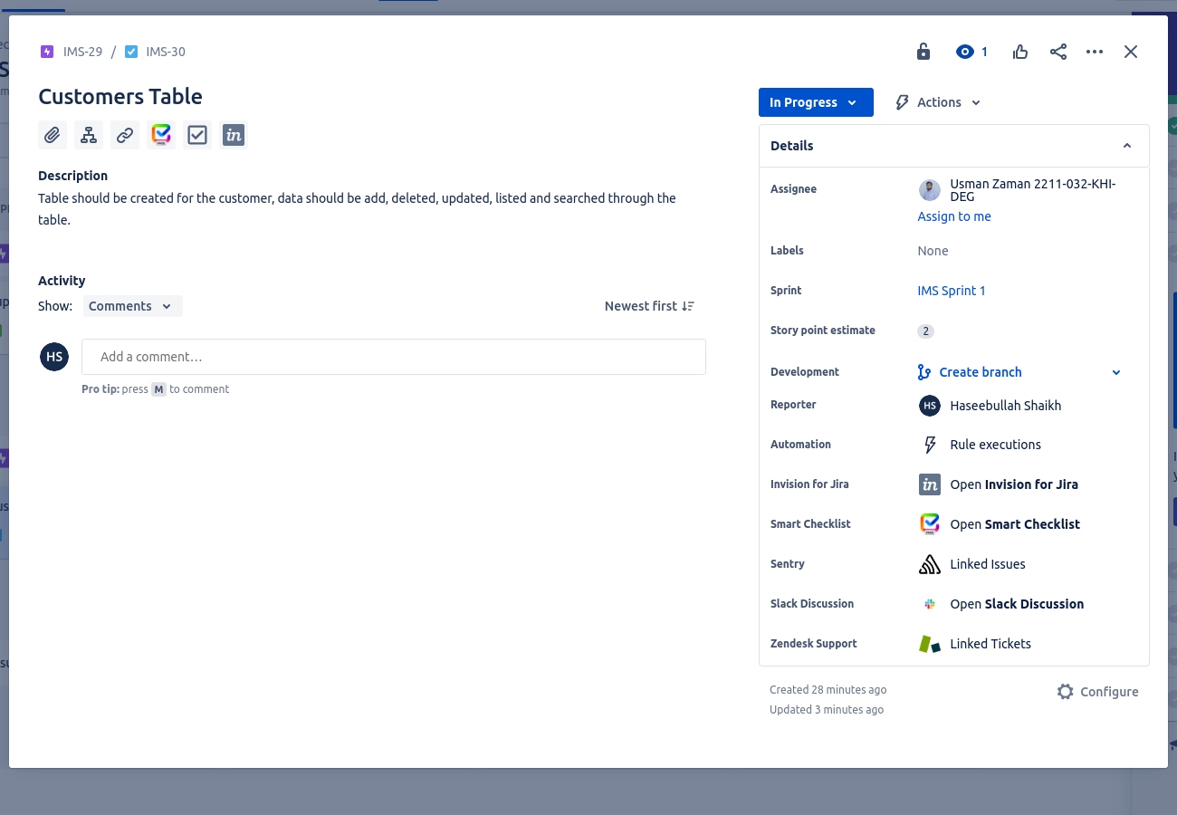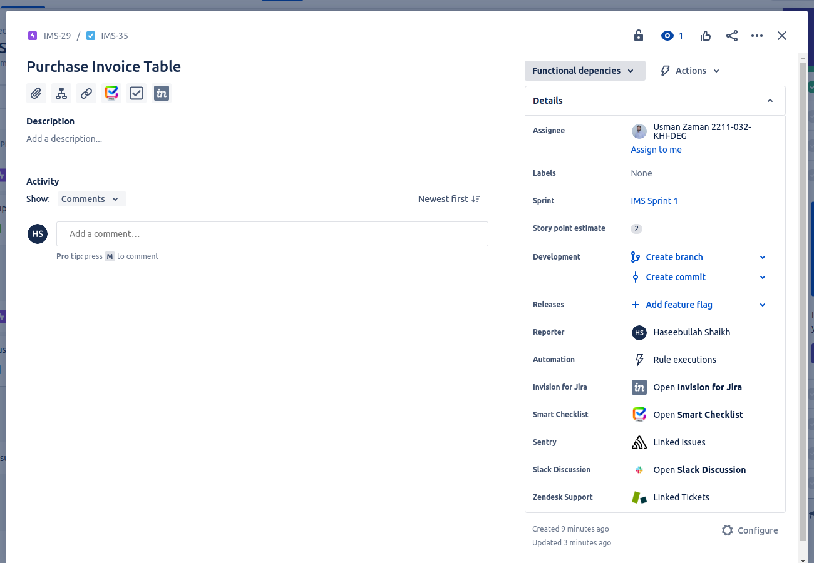

**The End ☺**